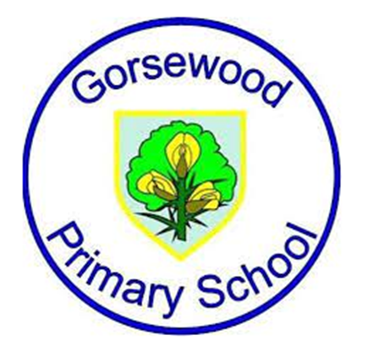

**GORSEWOOD PRIMARY SCHOOL**

**Long term overview - *Writing Roots Texts (Literacy Tree) - tbc throughout the year at salient times***

|  |  |  |  |  |  |  |
| --- | --- | --- | --- | --- | --- | --- |
| **Year group** | **Autumn 1** | **Autumn 2** | **Spring 1** | **Spring 2** | **Summer 1** | **Summer 2** |
| **Reception** | Whole School Book focus - ‘The Midnight Panther’ by Poonam Mistry  Where the Wild Things Are by Maurice Sendak  Bringing the rain to Kapti Plain by Verma Aardema | Look Up! By Nathan Byron & Dapo Adeola  Halibut Jackson by David Lucas | ‘.Little Red’ by Lynn and David Roberts  ‘Super Millie’ by Stephanie Clarkson | ‘The Extraordinary Gardner’ by Sam Boughton (EE has)  The Tiny Seed by Eric Carle | ‘The Naughty Bus’ by Jerry Oke & Jan Oke  ‘Night Pirates’ by Pete Harris & Deborah Allwright | Oi Frog by Kes Gray & Jim Field  And Tango makes Three by Justin Richardson & Peter Parnell |
| **Year 1**  **TBC** | Whole School Book focus - ‘The Midnight Panther’ by Poonam Mistry  Cave Baby by Julia Donaldson and Emily Graven  Astro Girl by Ken Wilson-Max | Billy the Beast by Nadia Shreen  Send for a Superhero by Michael Rosen | ‘Beegu’ by Alexis Deacon    ‘I want my hat back’ by Jon Classen | ‘The Odd Egg’ by Emily Gravett  ‘The Sea Saw’ by Tom Percival  ‘Dinosaurs and all that Rubbish by Michael Freeman | Lost and Found by Oliver Jeffers  Pig the Pug by Aaron Blabey | Iggy Peck Architect by Andrea Beaty & David Roberts  Julian is a Mermaid by Jessica Love |
| **Year 2** | Whole School Book focus - ‘The Midnight Panther’ by Poonam Mistry  Jim and the beanstalk by Raymond Briggs | Goldilocks and the Three Bears by Lauren Child  We are water protectors by Carole Lindstrom | The Minpins by Roald Dahl  ‘The Bear and the Piano’ by David Litchfield | ‘Dear Earth’ by Isabel Otter & Clara Anganuzzi  ‘Tadpoles Promise’ by Jeanne Willis | The Dragon Machine by Helen Ward  Ocean meets Sky by Eric Fan & Teyy Pan | The Great Fire of London by Emma Adams  A walk in London by Salvator Rubbino |
| **Year 3** | Whole School Book focus - ‘The Midnight Panther’ by Poonam Mistry  Leon and the place between by Angela McAllister | The BFG by Roald Dahl  The Heart and the Bottle by Oliver Jeffers | The Tin Forest by Helen Ward  ‘The Last Garden’ by Rachel Ip (CD has) | ‘Pied Piper’ by Michael Morpergo  ‘Escape from Pompeii’ by Christina Balit | The Mysteries Harris Burdick by Chris Van Allsberg  How to Live Forever by Colin Thompson | Jim a Cautionary Tale by Hilaire Belloc  Our Tower by Joseph Coelho |
| **Year 4** | Whole School Book focus - ‘The Midnight Panther’ by Poonam Mistry  Tar Beach by Faith Ringgold | FArTHER by Grahame Baker Smith  Varmints by Helen Ward | The Iron Man by Ted Hughes  ‘Winters Child’ by Angela McAllister | ‘Cinnamon’ by Neil Gaimin  ‘Frindleswylde’ by Natalia & Lauren O’Hara | The Ever Changing Earth by Grahame Baker-Smith  Shackletons Journey by William Grill | The Lion the Witch and the Wardrobe by CS Lewis  Jabberwocky by Lewis Carroll |
| **Year 5** | Whole School Book focus - ‘The Midnight Panther’ by Poonam Mistry  ‘Hidden Figures’ by Margot Lee Shetterly | Percy Jackson by Rick Riordan  The Man who Walked Between the Towers by Mordicai Gerstein | ‘The Tempest’ by William Shakespeare  ‘The Island’ by Armin Creder | The Sleeper and the Spindle by Neil Gaimen & Chris Riddell  ‘The Lizzie Belle Mysteries’ by J T Williams | The Children of Benin Kingdom by Dina Orji  Freedom Bird by Jerdine Nolen | High Rise by Sharna Jackson  Fire Bird by Saviour Pirotta & Catherine Hyde |
| **Year 6** | Whole School Book focus - ‘The Midnight Panther’ by Poonam Mistry  Windrush Child by Benjamin Zephaniah | Can we Save the Tiger? By Martin Jenkins  The Last Bear by Hannah Gold | Suffragette: ‘The Battle for Equality’ by David Roberts  ‘The Arrival’ by Shaun Tan | CONT -  ‘The Arrival’ by Shaun Tan  Goodnight Mr Tom by Michelle Magorian   * Other non fiction | Romeo and Juliet by William Shakespeare  ‘The Three Pigs Project’ by | Grimm Tales for Young and Old by Phillip Pullman |