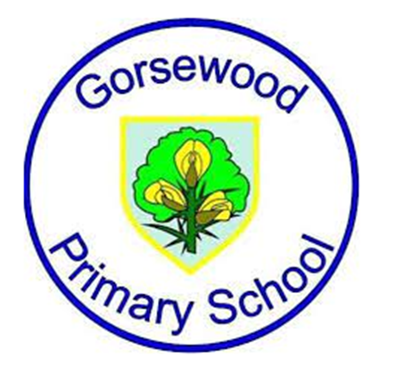

**GORSEWOOD PRIMARY SCHOOL**

**Long term overview - *COMPUTING***

| **Year group** | **Autumn 1** | **Autumn 2** | **Spring 1** | **Spring 2** | **Summer 1** | **Summer 2** |
| --- | --- | --- | --- | --- | --- | --- |
| **Reception** | **Online Safety** | **Information Technology** | **Computer Science**  Twinkl - Making a robot | **Computer Science**  Twinkl - Beebots | **Digital Literacy -** Editing Photos | **Digital Literacy** - Brushes |
| **Year 1** | **Common Sense Education**  **Digital Citizenship** | **Twinkl**  Computer Skills | **Twinkl**  Word Processing Skills | **Twinkl**  Programming Toys | **Twinkl**  Programming with ScratchJR | **Twinkl**  Using and Applying |
| **E-Safety ongoing throughout the year linked to PSHE and RSE.** | | | | | |
| **Year 2** | **Common Sense Education**  **Digital Citizenship** | **Twinkl**  Online Safety | **Twinkl**  Using the Internet | **CS First**  Introduction to CS First | **Twinkl**  Computer Art | **Twinkl**  Using and Applying |
| **E-Safety ongoing throughout the year linked to PSHE and RSE.** | | | | | |
| **Year 3** | **Be Internet Legends**  **Digital Wellbeing**  **Y3 Sharp Pillar**  **Y3 Alert Pillar** | **Be Internet Legends**  **Y3 Secure Pillar**  **Y3 Kind Pillar**  **Y3 Brave Pillar** | **CS First**  **CS First Unplugged** | **CS First**  **Storytelling Unit** | **CS First**  **Characterisation** | **CS First**  **An unusual Discovery** |
| **E-Safety ongoing throughout the year linked to PSHE and RSE.** | | | | | |
| **Year 4** | **Be Internet Legends**  **Digital Wellbeing**  **Y4 Sharp Pillar**  **Y4 Alert Pillar** | **Be Internet Legends**  **Y4 Secure Pillar**  **Y4 Kind Pillar**  **Y4 Brave Pillar** | **CS First**  **Music and Sound** | **CS First**  **Code your Hero** | **CS First**  **Interactive Presentation** | **CS First**  **CS First Unplugged** |
| **E-Safety ongoing throughout the year linked to PSHE and RSE.** | | | | | |
| **Year 5** | **Be Internet Legends**  **Digital Wellbeing**  **Y5 Sharp Pillar**  **Y5 Alert Pillar** | **Be Internet Legends**  **Y5 Secure Pillar**  **Y5 Kind Pillar**  **Y5 Brave Pillar** | **CS First**  **Friends** | **CS First**  **Animate a name** | **CS First**  **Dialogue** | **CS First**  **Narration** |
| **E-Safety ongoing throughout the year linked to PSHE and RSE.** | | | | | |
| **Year 6** | **Be Internet Legends**  **Digital Wellbeing**  **Y6 Sharp Pillar**  **Y6 Alert Pillar** | **Be Internet Legends**  **Y6 Secure Pillar**  **Y6 Kind Pillar**  **Y6 Brave Pillar** | **CS First**  **Create your own Google Logo** | **CS First**  **Design a game** | **CS First**  **Figurative Language** | **CS First**  **Pitch your Passion** |
| **E-Safety ongoing throughout the year linked to PSHE and RSE.** | | | | | |