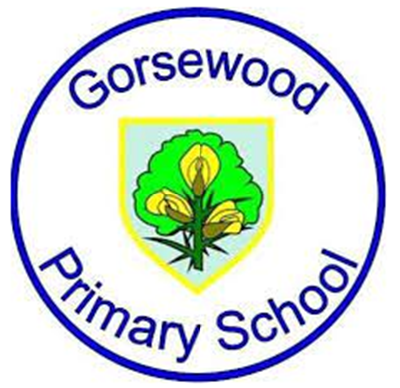
GORSEWOOD PRIMARY SCHOOL
Long term overview - SCIENCE

Year group | Autumn 1 | Autumn 2 | Spring 1 | Spring 2 | Summer 1 | Summer 2
Reception | Magical Me  Our body and the senses | Weather and Seasons | Magical Materials | Food and Plants | Animals and Their Life Cycles | Machines  Forces
Year 1 | All about me | Seasonal changes | Uses of Everyday Materials | Plants | All About Animals | Exploring Everyday Materials
Year 2 | Animals including Humans - Growth | Animals including Humans - Life Cycles | Uses of Everyday Materials | Plants | Living Things and Their Habitats | Living Things and Their Habitats from Around the World
Year 3 | Animals including Humans - What Makes Us | Rocks | Forces and Magnets | Plants | Scientific Enquiry | Light
Year 4 | Animals including Humans - Food and Digestion | Electricity | States of Matter | Living Things and Their Habitats - Conservation | Living Things and Their Habitats (classifying) | Sound
Year 5 | Animals including Humans - Life Cycles | Earth and Space | Properties of Materials | Changes of materials | Living things and their habitats | Forces
Year 6 | Animals including Humans | Electricity | Evolution and Inheritance | Looking After Our Environment | Living Things and Their Habitats | Light

